# **CHAPTER 4**

**PROJECT DESIGN**

# **4.1 MODULE DESCRIPTION OF ADMIN PHASE**

# 

# 

**4.1 FIGURE : ADMIN PHASE**

**Input :** Student image

**Output :** Model of the student

**Step 1 :** Addition of staff and students.

**Step 2 :** Storing the details of student and staff into the database.

**Step 3 :** Allowing students to capture the image.

**Step 4 :** Uploading the captured image of the student.

**Step 5 :** Using ML algorithm the training has been done for the uploaded image of

a particular student.

**Step 6 :** Model is generated for each student.

**Step 7 :** Generated models are stored in separate folders.

**Step 8 :** Save the folder name with the ID number of the student.

# **4.2 MODULE DESCRIPTION OF TEACHER PHASE**

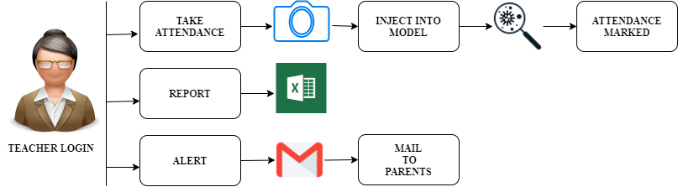

**4.2 FIGURE : TEACHER PHASE**

**Input :** Student image

**Output :** Attendance report.

**Step 1 :** Teacher allows students to capture images of the student.

**Step 2** **:**  Captured image is injected into the model.

**Step 3 :** The image is compared with the generated model.

**Step 4 :** By entering the corresponding roll number and subject code the attendance

will be marked.

**Step 5 :** If the model is not present it will prompt the staff to add the student.

**Step 6 :** Hence the attendance is stored in the Excel sheet.

**Step 7 :** In the report generation tab the staff can generate the attendance based on

hours and particular week and consolidated report.

**Step 8 :** Staff can send mail to the student parents about the daily presence of

student in the classroom.